# **II. Monitor**

Initial Condition

- Boot the system.

- Show on-screen the program in stand-by.

- Exit the program with red button.

Test Action

- Open the bash (ctrl + alt + t).

- Type in the bash ‘*tvservice -s*’.

Expected Result

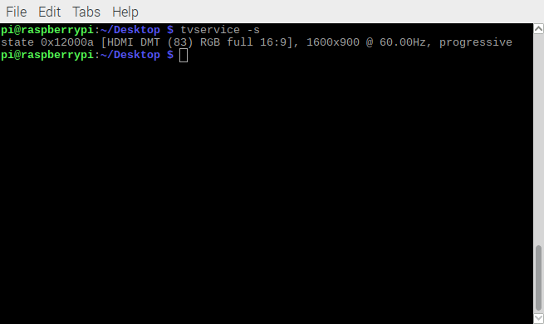- Show on-screen the specification of monitor.

**IV. Buttons**

4.1 Green button

Initial Condition

- Boot the system.

- Show on-screen the program in stand-by.

Test Action

- Push down the green button with connection to GPIO 17.

Expected Result

- Nothing here, the program can’t start if you don’t pull down the yellow button.

4.2 Yellow button

Initial Condition

- Boot the system.

- Show on-screen the program in stand-by.

Test Action

- Pull down the yellow button with connection to GPIO 27.

Expected Result

- The program wait for the employee’s badge.

4.3 Red button

Initial Condition

- Boot the system.

- Show on-screen the program in stand-by.

Test Action

- Pull down the red button with connection to GPIO 22.

Expected Result

- Close the program.

4.4 Power supply button

Initial Condition

- The system in poweroff.

Test Action

- Push down the white button with connection to GPIO 3

Expected Result

- Fail to push button, because is a switch button.